KCPD_BTL | plane of slab under bridge | 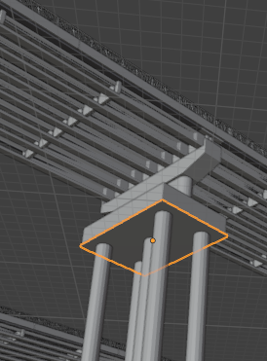
KCPT_K101_V2 | Support structure under bridge between road en pillar (x4) | 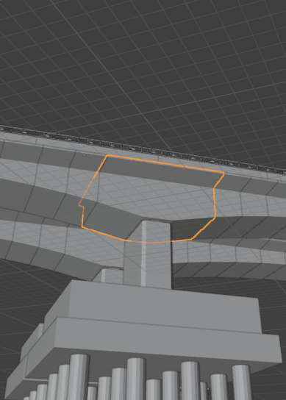
KCPD_BE MO | Plate before bridge (x8) | 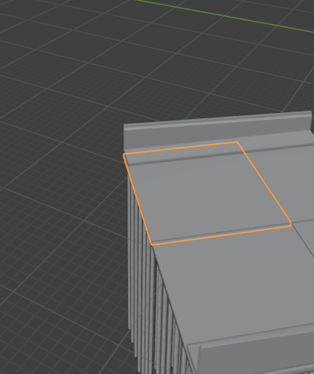
KCPD_BE TRU | Full slab under bridge | 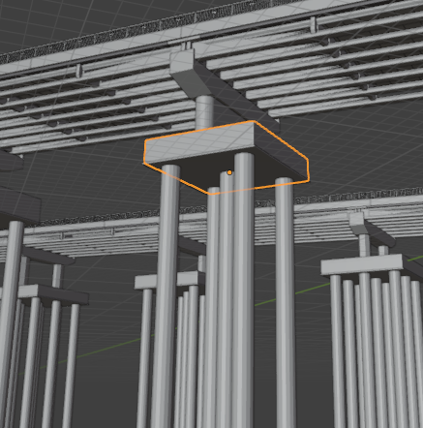
KCPT_Ki ( | Under road structure support | 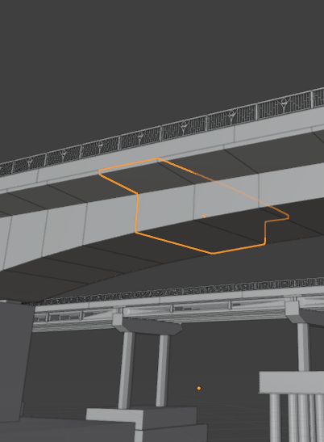
KCPD_THAN MO  (có ssẵn) | Support part only outside of bridge (x4) | 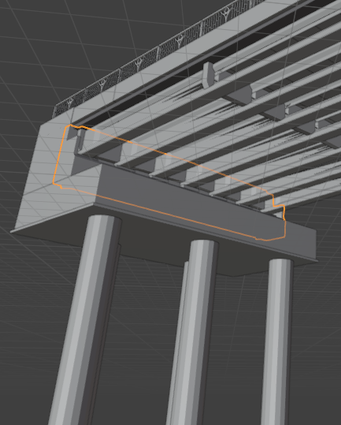
KCPD_THAN TRU DAC  (có sẵn) | Oval support pillar part | 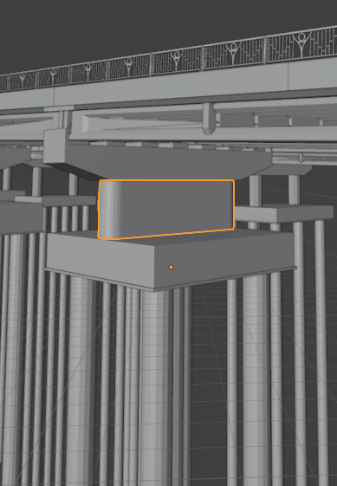
KCPT_DOT TREN DA  ( có sẵn) | Big under road support (x4) | 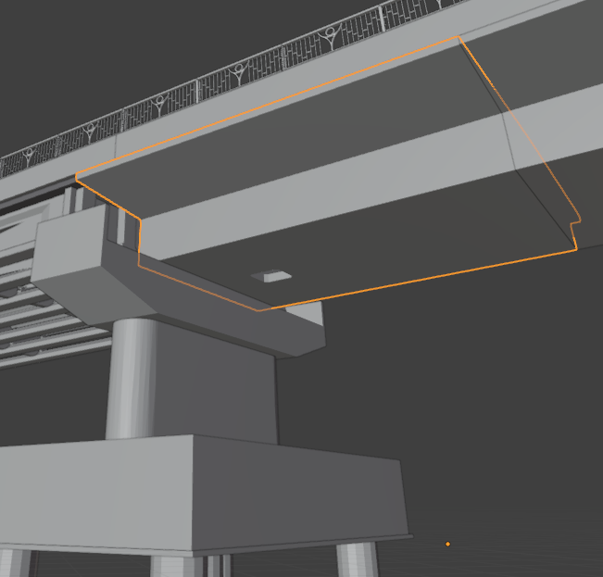
KCPT_I24  KCPT_I33 ( có sẵn) | Support beam under bridge | 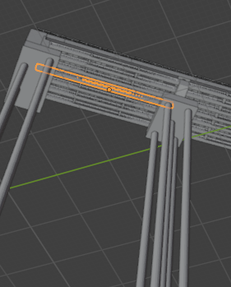
KCPD_TUONG | Side things at end of bridge (x4) | 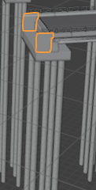
KCPD_XA MU_CUNG LOAI DAM ( có sẵn) | under bridge banana shaped support thing | 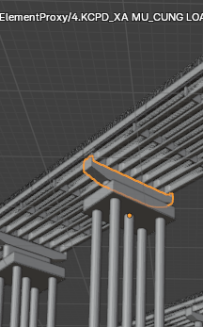
KCK_BAN QUA ( có ssẵn) | Small step piece end bridge | 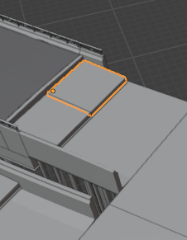
KCK_TUONG CHAN_MODULE (có sẵn) | Side piece end bridge (x6) | 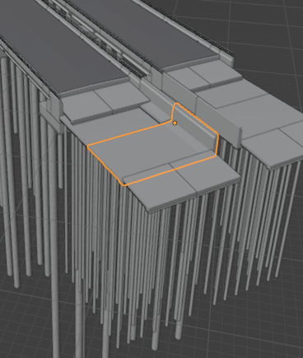
KCPD_COC | Pillar | 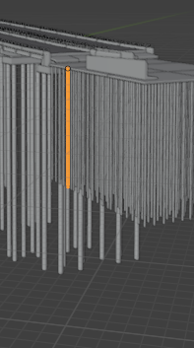
KCPT_BAN MAT (có sẵn) | Road piece | 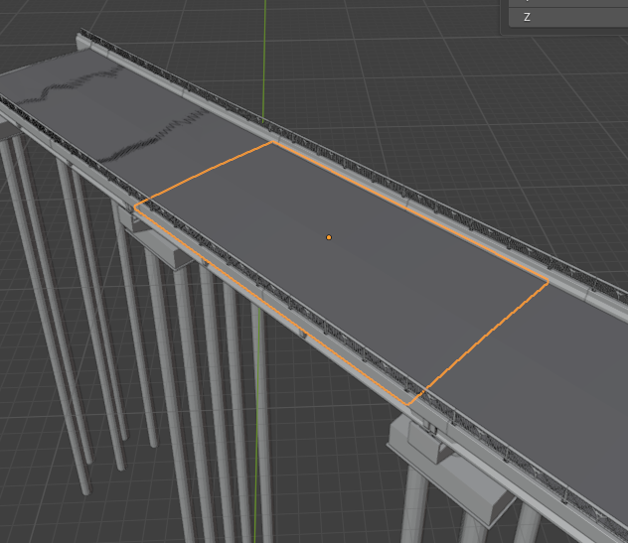
KCPT_GO LAN CAN (có sẵn) | side support thing for railing | 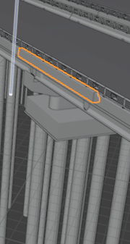
KCPT_LOP ( có sẵn) | Big road piece | 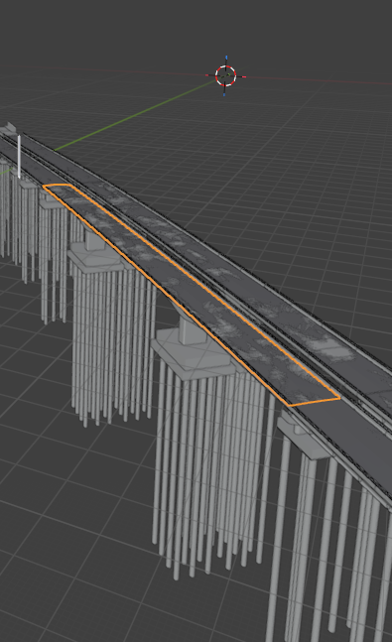
LOAI1_Thep hop ( có sẵn) | Top railing bar | 